Day 3 - VCS - Git & GitHub

Task: Establish a new directory, populate it with script files, initiate an empty repository on GitHub, convert the local directory into a Git repository, and link it to GitHub for pushing the code into the repository.

Added files to the directory and committed the changes to the local repo

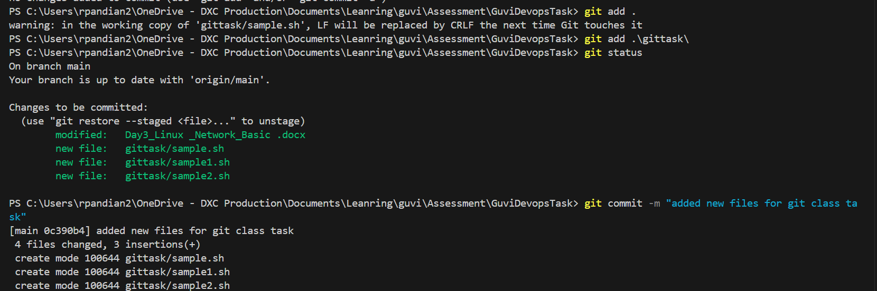

Pushing the changes to github

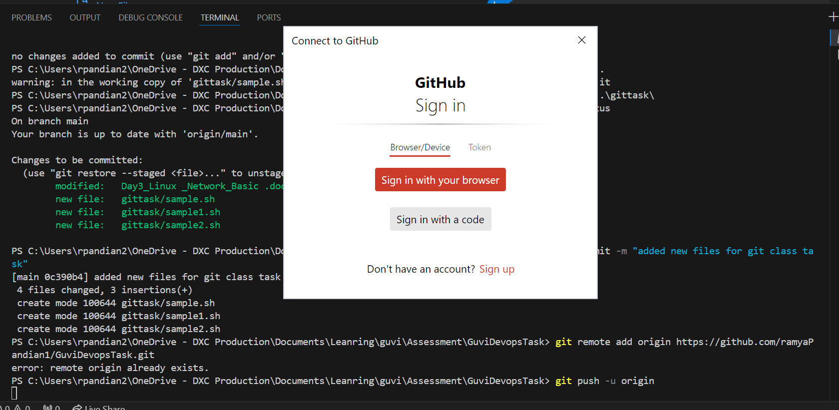

After pushing and authentication the folder created is visible on github

